**QUIZ 1**

**1.Which is the right output? ( B )**

**？X is 55 + (6 / 2).**

*A. X = 55 + (6 / 2).*

*B. X = 58*

*C. Error*

**2.Which is the right output？( A )**

goal

exit

redo

call

fail

***data(fact). data(rule).data(list).***

***cut_test_a(X) :-data(X).***

***cut_test_a('last clause').***

***cut_test_b(X) :-***

***data(X),***

***!.***

***cut_test_b('last clause').***

**？-cut_test_b(X), write(X), nl, fail.**



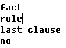

B

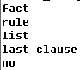C.

D. **Error**

3. **Which is the right output？( A )**

**?-a(b,c,d) = a(X,X,d).**

**?-a(c,X,X) = a(Y,Y,b).**

*A. no no*

*B. no yes*

*C. yes no*

*D. yes yes*

4.**Terms / Data types in Prolog can be? ( ABCD )**

*A. Integer B. Atom*

*C. Variable D. Structure*

1. **Please write the correct ports in Prolog goal?**

**6. Predict the results of these unification queries.**

?- a(b,c) = a(X,Y).

X = b,

Y = c

.

?- a(X,c(d,X)) = a(2,c(d,Y)).

X = Y, Y = 2.

.

?- a(X,Y) = a(b(c,Y),Z).

X = b(c, Z),

Y = Z.

.

?- tree(left, root, Right) = tree(left, root, tree(a, b, tree(c, d, e))).

Right = tree(a, b, tree(c, d, e)).

.

**QUIZ 2**

**1.** **What are the four items necessary for a PEAS description?**

**Performance,**

**Environment,**

**Actuators,**

**Sensors**

**2.** **What is the *evaluation of a search strategy* while measuring performance of searching?**

**Completeness:**

Can a solution eventually be found(Guaranteed)

Repeated states / loops / cycles can be avoided

**Optimality:**

Is the found solution the best among many solutions

**Time complexity:**

how long does it take to find a solution

**Space complexity:**

how much memory is needed to perform the search

**3. Please fill in the white squares (LXX) in the table below, and the words to be selected are**

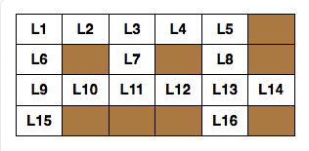

word(d,o,g).

word(r,u,n).

word(t,o,p).

word(f,i,v,e).

word(l,o,s,t).

word(m,e,s,s).

word(u,n,i,t).

word(f,o,r,u,m).

word(g,r,e,e,n).

word(s,u,p,e,r).

word(p,r,o,l,o,g).

word(v,a,n,i,s,h).

word(w,o,n,d,e,r).

word(y,e,l,l,o,w).

**Try to write a rule solution.**

solution(L1,L2,L3,L4,L5,L6,L7,L8,L9,L10,L11,L12,L13,L14,L15,L16):-

**word(L1,L2,L3,L4,L5),**

**word(L9,L10,L11,L12,L13,L14),**

**word(L1,L6,L9,L15),**

**word(L3,L7,L11),**

**word(L5,L8,L13,L16).**

**QUIZ 3**

**1.Given a data set S, as it shows in the table below. Please calculate the *information gain* of ‘outlook’: Gain(S,Outlook)=?.**

\**Please give the necessary calculation steps.*

|  |  |  |  |  |
| --- | --- | --- | --- | --- |
| **outlook** | **temperature** | **humidity** | **wind** | **playTennis** |
| sunny | hot | high | weak | no |
| sunny | hot | high | strong | no |
| overcast | hot | high | weak | yes |
| rain | mild | high | weak | yes |
| rain | cool | normal | weak | yes |
| rain | cool | normal | strong | no |
| overcast | cool | normal | strong | yes |
| sunny | mild | high | weak | no |
| sunny | cool | normal | weak | yes |
| rain | mild | normal | weak | yes |
| sunny | mild | normal | strong | yes |
| overcast | mild | high | strong | yes |
| overcast | hot | normal | weak | yes |
| rain | mild | high | strong | no |



1. Entropy(S) = -(9/14) log2 (9/14)

-(5/14) log2 (5/14)

= 0.94

2. Let ‘Outlook’ as the root node, we have:

Entropy(Sunny)= (-3/5)*log2(3/5)-(2/5)*log2(2/5) =0.971 ;

Entropy(Overcast)= (-1)*log2(1)-(1)*log2(1)=0.0 ;

Entropy(Rain)=0.971

3. Gain(Outlook)=0.940-(5/14)*Entropy(Sunny)

-(4/14)*Entropy(Overcast)

-(5/14)*Entropy(Rain)

=0.247

More details please find:

<http://axon.cs.byu.edu/~martinez/classes/478/stuff/labhints/decisionTreeHelp.html>

**2. Given a table as below, please calculate the 1st and 2nd iteration for the weights using the data from the first row of the table according to the BP (Backpropagation) neural network.**

**Active function(sigmoid): f(x)=**

**Learning rate：0.3**





1. Calculate the value of hidden and output layer

O(hidden input)=0.8*0.8+0.6*0.6=1

O(hidden output)= ****=0.73

O(output input)=0.73*0.5=0.365

O(output output)= ****=0.59



1. Error calculation for the 1st iteration



=0.59*(1-0.59)*(0.1-0.59)=-0.1185



=0.73*(1-0.73)*0.5*(-0.12)= -0.01168

 =0.3*(-0.1185)*0.73=-0.026

=0.3*(-0.01168)*0.8=-0.0028

=0.3*(-0.01168)*0.6=-0.0021

=0.5+(-0.026)= 0.474

=0.8+(-0.0028)= 0.7972

=0.6+(-0.0021)= 0.5979



1. Calculate the value of hidden and output layer of 1st iteration

O(hidden input)=0.8* 0.7972+0.6*0.5979=0.9965

O(hidden output)= ****=0.73

O(output input)= 0.73*0.474=0.346

O(output output)=****= 0.5856



1. Error calculation for the 2st iteration



=0.5856*(1-0.5856)*(0.1-0.5856)=-0.1178



=0.73*(1-0.73)*0.474*(-0.1178)= -0.0110

 =0.3*(-0.1178)*0.73=-0.0258

=0.3*(-0.0110)*0.8=-0.00264

=0.3*(-0.0110)*0.6=-0.00198

=0.474+(-0.0258)= 0.4482

=0.7972+(-0.00264)= 0.79456

=0.5979+(-0.00198)= 0.59592



1. Calculate the value of hidden and output layer of 2nd iteration

O(hidden input)=0.8* 0.79456+0.6*0.59592

=0.9932

O(hidden output)= ****=0.7297

O(output input)= 0.7297*0.4482=0.327

O(output output)=****= 0.581



This one hidden layer network is very simple just for easy calculation by hand, following shows another sample of a normal BP neural network to solve the XOR problem, which has 3 input layer, 4 hidden layer and one output layer coded with Python.

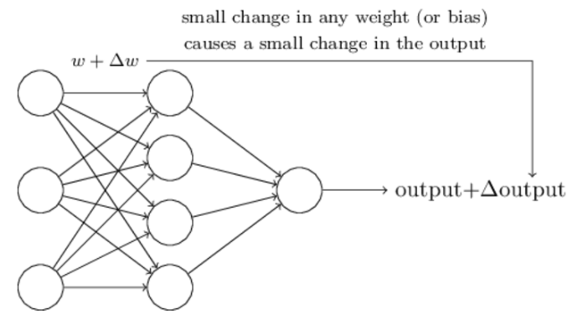

BP_XOR.py:

# -*- coding: utf-8 -*-

import numpy as np

#Input data

X = np.array([[1,0,0],

[1,0,1],

[1,1,0],

[1,1,1]])

#label

Y = np.array([[0,1,1,0]])

#Initial weights，[-1,1]

V = np.random.random((3,4))*2-1

W = np.random.random((4,1))*2-1

print(V)

print(W)

#learning rate

lr = 0.11

def sigmoid(x):

return 1/(1+np.exp(-x))

#derivation

def dsigmoid(x):

return x*(1-x)

def update():

global X,Y,W,V,lr

#Input,output,weights,weights,learn rate

# L1：Input -->hidden ；3X4

# L2：hidden--> output；1

L1 = sigmoid(np.dot(X,V))#output of hidden layer(4,4)

L2 = sigmoid(np.dot(L1,W))#output of output layer(4,1)

# L2_delta：error of output

# L1_delta：error of hidden

L2_delta = (Y.T - L2)*dsigmoid(L2)

L1_delta = L2_delta.dot(W.T)*dsigmoid(L1)

# W_C：weights changing from input to hidden layer

# V_C：weights changing from hidden to output layer

W_C = lr*L1.T.dot(L2_delta)

V_C = lr*X.T.dot(L1_delta)

W = W + W_C

V = V + V_C

for i in range(20000):

update()#updata weights

if i%500==0:

L1 = sigmoid(np.dot(X,V))#output of hidden layer(4,4)

L2 = sigmoid(np.dot(L1,W))#output of output layer(4,1)

print('Current Error:',np.mean(np.abs(Y.T-L2)))

L1 = sigmoid(np.dot(X,V))#output of hidden layer(4,4)

L2 = sigmoid(np.dot(L1,W))#output of output layer(4,1)

print(L2)

def judge(x):

if x>=0.5:

return 1

else:

return 0

for i in map(judge,L2):

print(i)

#test a new data

X = np.array([[1,0,1],

[1,1,1],

[1,1,0],

[1,0,0]])

L1 = sigmoid(np.dot(X,V))#output of hidden layer(4,4)

L2 = sigmoid(np.dot(L1,W))#output of output layer(4,1)

def judge(x):

if x>=0.5:

return 1

else:

return 0

#

for i in map(judge,L2):

print(i)